[Electro Mechanical System Lab]
[OEL Experiment Report]

[Speed Control of DC Shunt Motor]
Submitted by:
Ali Asghar 22L-6265
Haseeb ur Rehman 22L-6234
Sara Saif 22L-7734 Zaid Kamran 22L-7671
Submitted to:
[S M Ismail]
[17 May 2024]
Department of Electrical Engineering
National University of Computer and Emerging Sciences, Lahore _________________________________________________________________ Table of Contents

__________________________________________________________
- Introduction
- Problem Analysis
- Design Requirements
- Feasibility Analysis
- Possible Solutions
- Preliminary Design
- Design Description
- Software Simulation
- Experimental Results
- Performance Analysis
- Future Scope
- Social and Cultural Implications
- Conclusion __________________________________________________________

Introduction

__________________________________________________________
DC machines are versatile electrical devices that either convert electrical energy into mechanical energy or transform mechanical energy into electrical energy, depending on their function. They play a crucial role in various applications, including electric vehicles, industrial machinery, and power generation systems. DC machines are divided into two primary types: DC motors and DC generators.
- DC-Motors:
DC motors are devices that convert electrical energy into mechanical energy. They function based on the principle of the Lorentz force, where a current-carrying conductor in a magnetic field
- DC -Generators:
DC generators, also known as dynamos, are devices that transform mechanical energy into electrical energy. They operate on the principle of electromagnetic induction. When a conductor moves within a magnetic field, it induces an electromotive force (EMF) in the conductor, generating electricity.
Speed Control Methods for DC Machines:
- Armature Voltage Control
- Field Flux Control
- Armature Resistance Control
- Voltage Control Method
- PWM (Pulse Width Modulation) Control

Problem Analysis
The main challenge is designing a control circuit that can precisely and consistently adjust a DC shunt motor's speed within a specific range. Unlike fixed-speed motors that operate at a constant pace, the DC shunt motor requires variable speed regulation to adapt to changing operational demands.
Selecting the correct resistors for the control circuit is essential for accurate speed control. These resistors are crucial for regulating the voltage applied to the motor, which directly affects its rotational speed.
Additionally, the design must ensure that the motor's speed stays within the designated range, including both the motor's rated speed (S Rated) and a predetermined speed (S2). Achieving this balance requires careful calculation and calibration to fine-tune the voltage control in relation to motor performance.
The challenge involves not only the technical aspects of circuit design but also the precision and accuracy needed to maintain the specified speed range. Successfully overcoming these obstacles will enable the creation of a reliable control circuit that provides the DC shunt motor with flexible speed control, enhancing its effectiveness in various applications.
__________________________________________________________ Design Requirements
To achieve the necessary speed control, the first step is to select resistors from the provided list. The resistor values are crucial because they regulate the voltage applied to the motor, which affects its speed. By carefully selecting these resistor values, we can ensure precise control over the motor's rotational speed.
Designing the circuit to efficiently adjust the motor's speed within the designated range is essential. This involves using the provided formula to determine the correct resistor values and integrating them into the circuit. The chosen resistors should enable precise and smooth speed control, allowing the motor to operate within the desired range.
To evaluate the control circuit's effectiveness, we can use simulation software to model its behavior under various conditions. Simulating the circuit helps identify potential issues or optimizations before actual implementation.
Experimental testing is necessary to assess the control circuit's performance in real-world conditions. This involves building a circuit prototype and connecting it to the DC shunt motor. By following systematic testing protocols, we can evaluate the circuit's accuracy in controlling the motor's speed within the required range. Any discrepancies between expected and actual results are analyzed, and adjustments are made to optimize performance.

__________________________________________________________

Feasibility Analysis
While the project appears manageable due to the availability of required components and the simplicity of the speed control formula, the main challenge lies in selecting the correct resistor combination to precisely achieve the desired speed range.
With various available methods to attain the necessary speed control using the provided resistors, the difficulty lies in determining the resistor combination that will result in the total resistance value needed to effectively regulate the motor's speed.
Although the speed control formula is straightforward, its application requires careful consideration of several factors, including section and registration numbers. Accurately calculating the preset speed (S2) is essential for selecting the appropriate resistor values.
For the control circuit to operate effectively, achieving precise speed control within the specified range is crucial. Even minor variations in resistor values can lead to significant fluctuations in motor speed. Hence, selecting the appropriate mix of resistors is vital to ensure that the motor operates within the intended speed range.
To enhance the circuit's performance, an iterative approach may be necessary due to the challenge of selecting the optimal resistor combination. This involves experimenting with different resistor combinations, analyzing their impact on speed control through simulation, and sadjusting the values as required to achieve the desired outcome.

Possible Solution
Several strategies can be explored to tackle the challenge of accurately selecting the appropriate resistors to achieve the desired speed range.
The initial step involves determining the resistor values needed to attain the target speed using the provided formula (S2). By inputting the section number and registration number into the formula:
𝑆2=𝑆𝑅𝑎𝑡𝑒𝑑+100×𝑠𝑒𝑐𝑡𝑖𝑜𝑛_𝑛𝑢𝑚𝑏𝑒𝑟+𝐿𝑎𝑠𝑡 2 𝑑𝑖𝑔𝑖𝑡𝑠 𝑜𝑓 𝑟𝑒𝑔𝑖𝑠𝑡𝑟𝑎𝑡𝑖𝑜𝑛 𝑛𝑢𝑚𝑏𝑒𝑟S2=SRated+100×section_number+Last2digitsofregistrationnumber
we can calculate the target speed that the control circuit must regulate the motor to.
Once the calculated resistor values are determined, the subsequent action is to choose resistors from the available inventory that closely match these values. There is flexibility in selecting components that align with the computed values.
Following this, the circuit's performance is refined iteratively after selecting the initial resistor combination. This iterative process entails testing the circuit with the chosen resistor values, evaluating the motor's speed response, and making adjustments as necessary to achieve the desired speed control within the specified range.
Simulation tools can aid in observing the circuit's behavior with different resistor combinations. By analyzing simulation results, potential improvements can be identified, and resistor values can be adjusted to enhance the circuit's performance. This iterative approach to simulation-based control circuit design optimization facilitates quick experimentation and refinement.
This outlines the preliminary design process for achieving precise speed control with the DC shunt motor.

Preliminary Design
To commence, we'll scrutinize the provided formula to determine the motor's speed (S2) and ascertain the resistor values required to achieve the desired speed range. By plugging in our section number and the final two digits of our registration number into the equation, we'll compute the precise value of S2.
Once we've derived the S2 speed, we'll proceed to select suitable resistor values from the predefined list. This might involve utilizing a single resistor from the list or combining multiple resistors in series or parallel configurations to attain the desired resistance value.
Following the determination of resistor values, we'll contemplate their placement in the circuit layout to optimize efficiency and performance. This involves defining the role of each resistor within the circuit and ensuring that their connections are arranged to minimize power losses and signal degradation.
We'll also evaluate how the placement of resistors affects circuit stability and reliability, considering factors such as noise reduction and heat dissipation. By strategically situating the resistors within the circuit, we can mitigate interference and enhance speed control efficiency.
In essence, the initial design concept will guide the selection and positioning of components in the control circuit, with a particular emphasis on resistor values and configurations conducive to maximizing the DC Shunt Motor's desired speed range. This thorough analysis of component selection and arrangement will lay the groundwork for developing a robust and dependable control circuit.

Design Description
In this segment, we'll provide an in-depth explanation of the selected design for the control circuit, offering detailed insights into its components, configuration, and performance characteristics.
Initially, we'll present a circuit diagram illustrating how the components of the control circuit are interconnected and arranged. This diagram will depict the DC Shunt Motor, power supply, control elements (such as amplifiers and resistors), and any feedback mechanisms employed for speed regulation.
The determined speed (S2) obtained from the previously mentioned formula will guide the precise selection of resistor values for the control circuit. By inputting the last two digits of the registration number and the relevant section number, we'll determine the exact resistor values necessary to achieve the desired speed range for the DC Shunt Motor. These resistor values will be selected from a predefined list to ensure component availability and compatibility.
The relationship between the chosen resistor values and the estimated motor speed (S2) will be demonstrated through detailed computations. To validate the chosen design approach and ensure its practicality and effectiveness in regulating motor speed within the specified range, this may involve simulations or mathematical analyses.
The design will be further refined to enhance reliability, minimize power losses, and ensure precise speed control. This refinement process may involve adjustments to circuit designs or resistor values to optimize performance parameters such as stability, speed accuracy, and response time. Considerations such as thermal management, noise reduction, and component selection will be integrated to improve the overall durability and efficiency of the circuit.

____________________________________________________________ Software Simulation

__________________________________________________________
During this project phase, software simulations will be instrumental in validating the control circuit's design and forecasting its performance under diverse operational scenarios. By employing software simulations, we can scrutinize the circuit's performance metrics and conduct a thorough assessment of its behavior without resorting to physical prototyping.
Proteus will be utilized to accurately simulate the control circuit's behavior, considering the previously outlined circuit diagram and component specifications. This involves inputting the circuit parameters into the simulation environment to create a virtual model of the control circuit, encompassing resistor values, voltage sources, and motor characteristics.
Subsequently, simulations will be conducted to evaluate the control circuit's performance across different operational conditions. This may involve analyzing power consumption, stability, transient response, and speed regulation across varying input voltages and load levels. By systematically adjusting simulation parameters, we can gain valuable insights into the circuit's behavior and identify any potential design flaws or areas for optimization.

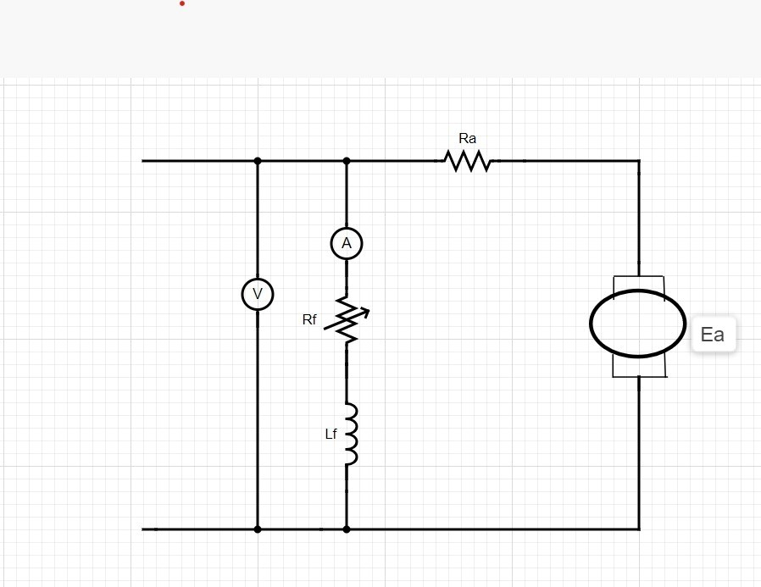

__________________________________________________________ Experimental Results
______________________________________________________________
In this project phase, practical experiments will be carried out to validate the functionality and effectiveness of the designed control circuit in regulating the speed of the DC Shunt Motor. These experiments are crucial for confirming the circuit's real-world performance and ensuring its reliability and stability under varying load conditions.
Tests will be conducted under various load conditions to simulate realistic operating scenarios encountered in practical applications. This may involve adjusting the mechanical load on the motor shaft or modifying the electrical load across the motor terminals to assess the circuit's response to changing demand conditions.
Experimental data will be collected and analyzed to assess the control circuit's performance in regulating motor speed under different operating conditions. Any observed trends, anomalies, or areas for improvement will be thoroughly documented and reported, along with recommendations for optimizing or refining the circuit design.
To analyze the experimental results, the following formula will be employed:
𝑆2=𝑆𝑅𝑎𝑡𝑒𝑑+100×𝑠𝑒𝑐𝑡𝑖𝑜𝑛_𝑛𝑢𝑚𝑏𝑒𝑟+𝐿𝑎𝑠𝑡 2 𝑑𝑖𝑔𝑖𝑡𝑠 𝑜𝑓 𝑟𝑒𝑔𝑖𝑠𝑡𝑟𝑎𝑡𝑖𝑜𝑛 𝑛𝑢𝑚𝑏𝑒𝑟S2=SRated+100×section_number+Last2digitsofregistrationnumber

The table is given below:
Speed | Speed | Resistor
S2-50 | 1439 | 609.080
S2-100 | 1451 | 613.88
S2-150 | 1418 | 599.92
______________________________________________________________ Performance Analysis

__________________________________________________________
___ In this project phase, we will utilize experimental data gathered from real-world testing to evaluate the performance metrics of the control circuit. The primary aim of this analysis is to assess how effectively the circuit meets the design standards and identify areas for improvement by examining key metrics such as speed regulation, efficiency, and stability.
Speed regulation refers to the control circuit's ability to maintain the motor speed within a predetermined range under varying load conditions. To gauge the precision and responsiveness of the speed control system, we will calculate metrics such as steady-state error and overshoot, comparing the actual motor speed with the target set-point.
Efficiency serves as a crucial performance indicator, indicating how efficiently the control circuit converts electrical energy into motor drive while minimizing losses. By considering factors such as voltage drop across resistors, power dissipation in semiconductor devices, and mechanical losses in the motor, we will assess the circuit's input and output powers. Analyzing the input-output power ratio will enable us to evaluate the overall effectiveness of the control circuit and identify areas for optimization to reduce energy losses and enhance system efficiency.
Stability analysis aims to determine whether the control circuit remains stable and predictable across various operating conditions by examining its transient behavior and dynamic responsiveness. Evaluating stability metrics such as gain and phase margins, transient response time, and frequency response characteristics will help determine the stability margins and robustness of the circuit. To enhance circuit stability, any observed oscillations, nonlinear behavior, or instabilities during testing will be thoroughly investigated to identify their potential causes and implement corrective measures.

_______________________________________________________ Future Scope

__________________________________________________________
__
This section will offer recommendations for additional refinements and enhancements to the control circuit design, as well as explore potential applications in related domains. These suggestions aim to bolster the current design by addressing any shortcomings or areas requiring optimization, while also exploring avenues to expand the control circuit's versatility and adaptability for various uses.
Exploring state-of-the-art control strategies that surpass conventional approaches is one avenue for improvement. Implementing techniques like adaptive control, predictive control algorithms, or model-based controllers could enhance speed regulation, responsiveness, and stability. By harnessing advanced control methodologies, we can effectively tackle complex control challenges in dynamic operational scenarios and further refine the performance of the control circuit.
To achieve precise and accurate speed control, integrating feedback devices such as position encoders, velocity sensors, or current sensors can be advantageous. These devices provide real-time feedback to the control circuit, enabling improved speed regulation and responsiveness. Feedback-based control strategies, such as adaptive control algorithms and proportional-integral-derivative (PID) control, can dynamically adjust motor speed based on sensor feedback, thereby enhancing the robustness of the control circuit design.
________________________________________________________ Social and Cultural Implications

__________________________________________________________
This project is dedicated to thoroughly examining its social and cultural implications, particularly regarding occupational safety and environmental sustainability. Prioritizing the well-being of project participants and the broader community is paramount, ensuring compliance with legal and ethical standards.
Throughout every stage of the project lifecycle, from conception to operation, utmost attention will be given to ensuring worker safety. This involves identifying and mitigating risks of electrical, thermal, and mechanical injuries during the construction and testing of the control circuit. Strict adherence to safety regulations and procedures will be enforced to minimize workplace accidents and injuries.
To minimize its environmental footprint and promote responsible resource utilization, the project will integrate principles of environmental sustainability. This entails employing energy-efficient design techniques, minimizing waste generation, and using eco-friendly materials for the control circuit. Efforts will be made to reduce energy consumption, emissions, and optimize resource utilization to mitigate the project's negative environmental impact.
______________________________________________________________ Conclusion

__________________________________________________________
In summary, crafting a control circuit for a DC shunt motor presents both opportunities for creativity and hurdles to overcome. Throughout this project, we've adeptly maneuvered through complexity and uncertainty, addressing design limitations and achieving desired outcomes through a blend of knowledge and innovative thinking.
Our approach to designing the control circuit involved careful consideration of various design philosophies and component choices, balancing factors such as cost-effectiveness, motor compatibility, and performance requirements. The result is a control circuit that not only meets speed regulation specifications but also operates with resilience, dependability, and efficiency.
Through thorough analysis, testing, and evaluation, we've gained valuable insights into the behavior and performance of the control circuit across diverse operating conditions. Software simulations have provided predictive insights, while practical trials have empirically validated functionality and performance.
Our commitment to innovation drives us to explore avenues for further improvements and optimizations in the control circuit architecture. By integrating cutting-edge control strategies, implementing feedback mechanisms, and selecting optimal components, we aim to enhance the circuit's performance and adaptability, creating new opportunities for application across various industries.
In conclusion, the process of designing a control circuit for a DC shunt motor has been one of accomplishment, creativity, and exploration. Our team's dedication to excellence has resulted in a control circuit that not only meets requirements but also paves the way for advancements in motor control technology, opening doors to new possibilities.

